



Case study
Integrated Project
LAB MANUAL

Disclaimer: The content is curated from online/offline resources and used for educational purpose only
Lab No – Case study (Integrated Project Lab)
Objective:
- Use Microsoft Excel Copilot to clean and analyze retail sales data.
- Apply GitHub Copilot to generate Python code for basic demand forecasting.
- Explore cloud data storage and services using Microsoft Azure.
- Demonstrate how AI tools can support data-driven decision making in retail analytics.
Equipment Required:
- Computer system with internet connection
- Microsoft Excel Copilot (Microsoft 365 account with Copilot enabled)
- Visual Studio Code with Python installed
- GitHub Copilot enabled in VS Code
- Microsoft Azure account
- Sample retail sales dataset
Prerequisites:
Students should have basic knowledge of:
- Spreadsheet operations (tables, formulas, charts)
- Basic Python programming concepts
- Introduction to cloud computing
- Familiarity with AI-assisted tools such as Copilot
Problem Statement:
Large retail organizations such as Walmart analyze large volumes of sales data to forecast product demand and manage inventory efficiently. Traditional manual analysis can be time-consuming and may not capture hidden trends in large datasets.
In this lab, students will simulate a simplified retail analytics workflow. Using AI-powered tools, they will clean and analyze sales data, generate insights, and develop a basic forecasting script to understand future demand patterns. The processed data and analysis will then be explored within a cloud environment.
The objective is to understand how AI-assisted productivity tools and cloud platforms can work together to support modern data analytics workflows.
Aim of the Integrated Project
- Task 1 – Data collection
- Task 2 – Data cleaning with Excel Copilot & Visualization
- Task 3 – Demand forecasting with GitHub Copilot
- Task 4 – Cloud Exploration -Upload dataset to Azure

Procedure:
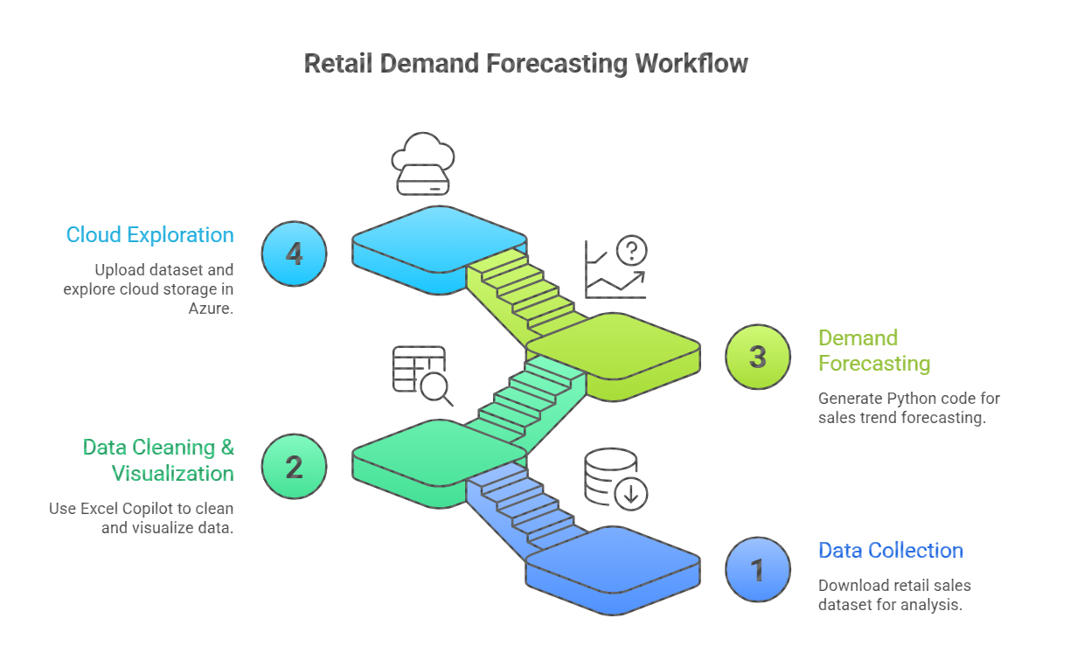
Task 1: Data Collection
To obtain a real-world retail sales dataset that will be used for data analysis, forecasting, and cloud-based exploration in the case study.
Dataset Source
This lab uses the Walmart Store Sales Forecasting dataset, a publicly available dataset used for studying retail demand patterns.
Dataset Link:
Regression-Based Sales Prediction for Walmart Stores | Spreadsheet Download | Gigasheet
The dataset contains historical weekly sales records from multiple retail stores, including sales values and contextual indicators such as holidays.
Step 1:
Open a web browser and navigate to the dataset page:
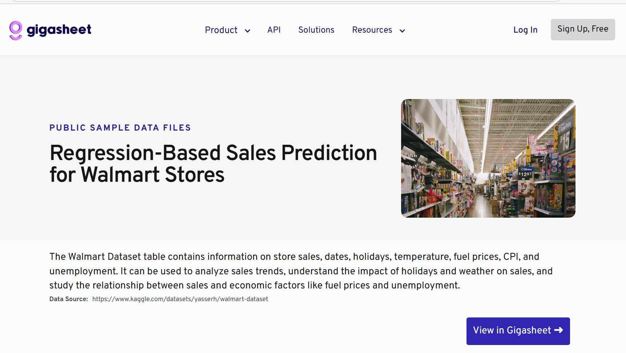

Step 2:
Download the Walmart dataset (CSV or Excel) from the Gigasheet interface.
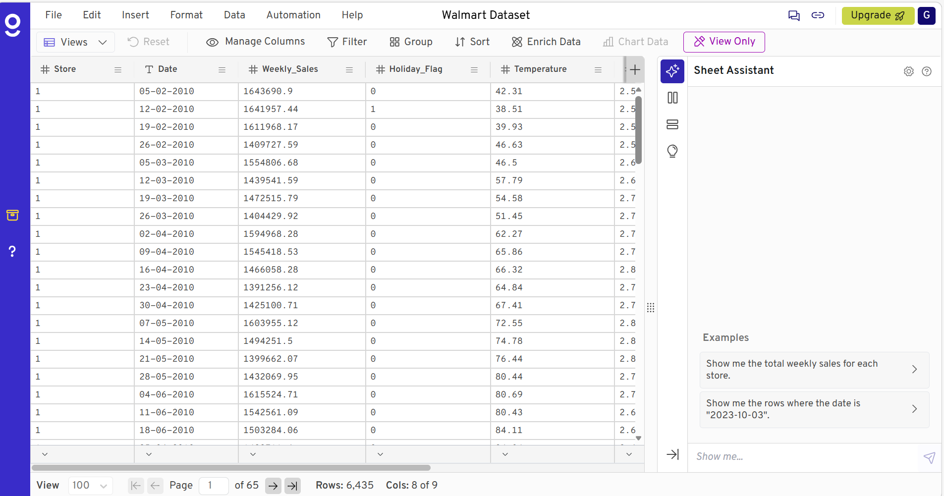
Step 3:
Save the file in your project directory as:
data/walmart_sales.csv
Step 4:
Extract the downloaded ZIP folder to your local system.

Task 2: Data Cleaning and Visualization
Clean the retail dataset and generate basic insights using Microsoft Excel Copilot.
Step 1:
- Open the Dataset in Excel
  - Open the walmart_sales.csv dataset in Microsoft Excel.

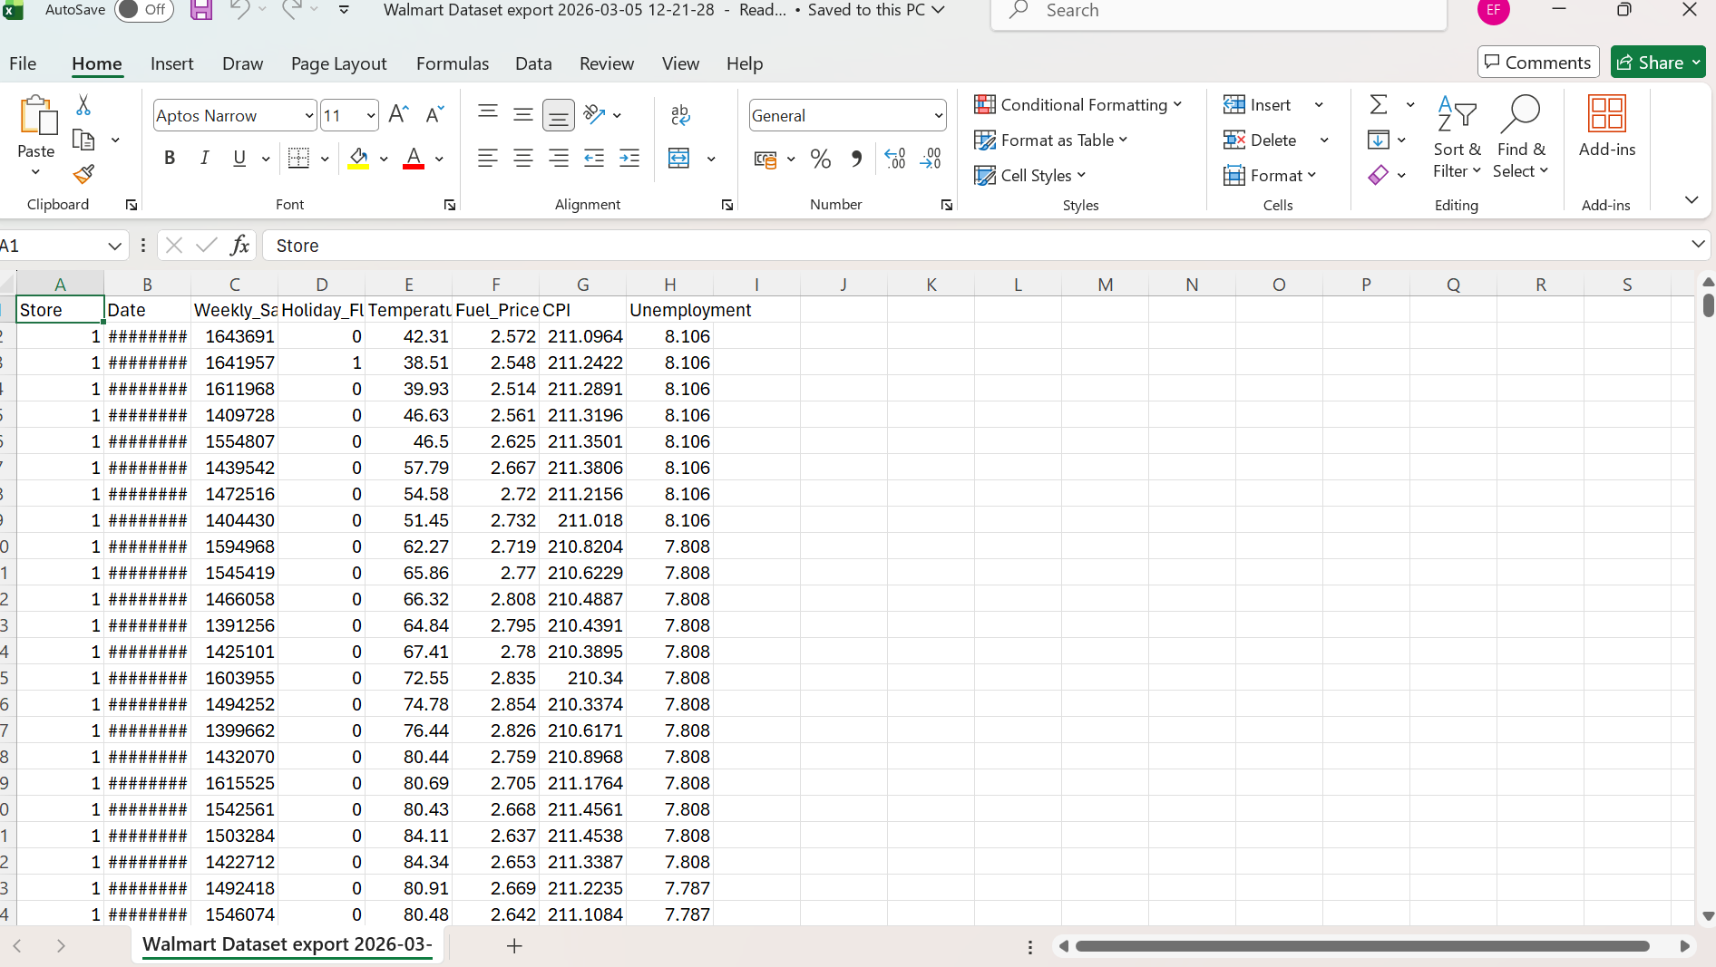
Step 2:
- Inspect the Dataset
Review the columns to understand the available attributes such as:
- Store
- Dept
- Date
- Weekly_Sales
- IsHoliday
Step 3:
- Clean the Dataset
Use Excel Copilot or Excel tools to perform basic cleaning tasks:
- Check for missing values
- Remove duplicate records
- Ensure date format consistency
- Verify numeric formatting of sales values
Example Copilot prompt:
"Identify missing values and summarize the dataset."
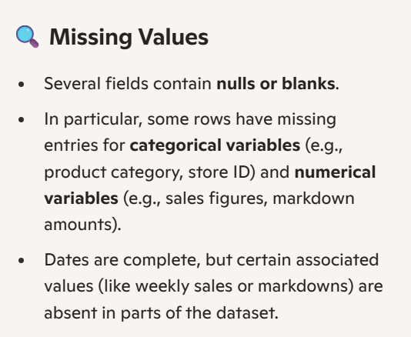
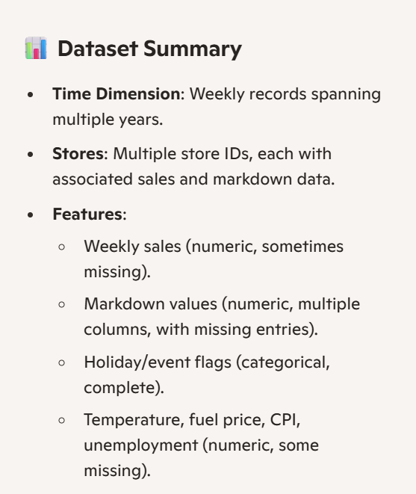
Step 4:
- Generate Data Summaries
Use Excel Copilot to create:
- Summary statistics of sales
- Average sales per store
- Weekly sales trends
Example prompt:
"Show average weekly sales by store."

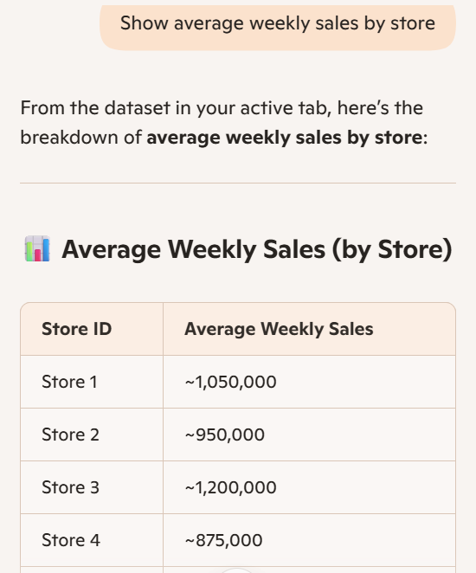
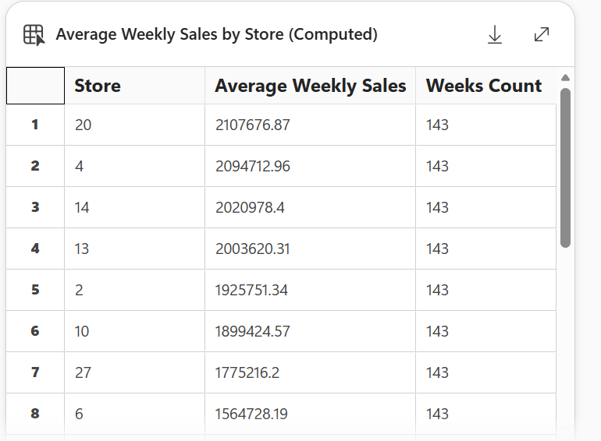

Step 5:
- Create Visualizations
Use Excel charts to visualize patterns in the data such as:
- Sales trend over time
- Sales comparison across stores
- Holiday vs non-holiday sales patterns
Example Copilot prompt:
"Create a chart showing weekly sales trend."
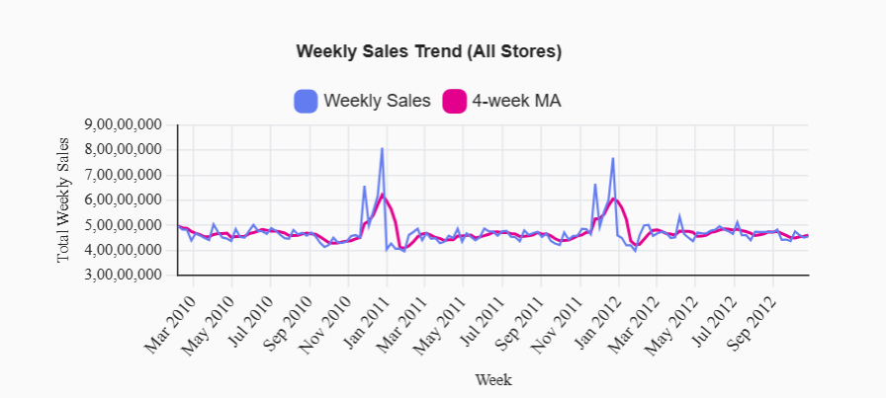
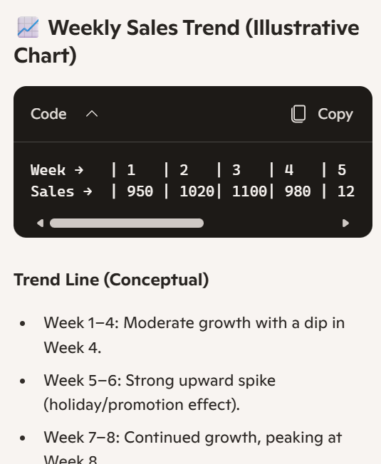
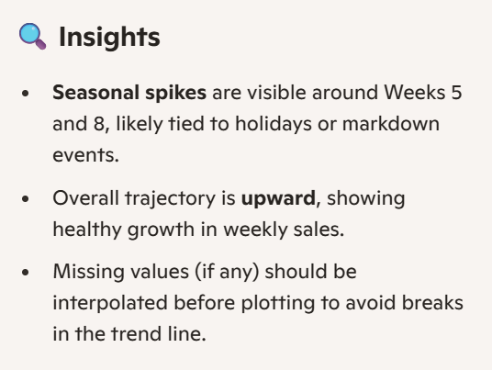

Task 3 : Demand Forecasting Using Python & Copilot
Step 1:
- Open VS Code or GitHub Codespaces with Copilot enabled.
Step 2:
- Load the cleaned Walmart dataset from Step 2:
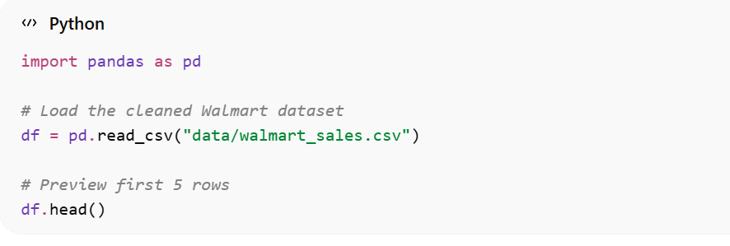
Step 3:
- Preprocess Data
  - Convert Date to datetime
  - Aggregate sales if needed
- Visualize Weekly Sales
- Build a Simple Forecasting Model
  - Using Linear Regression (easy for lab demo)
- Plot Actual vs Predicted
- Forecast Next 4 Weeks
- In a Python file or Jupyter notebook in GitHub, type a Copilot prompt such as:
- "Create a demand forecasting model for Weekly_Sales"
- "Train and predict next 4 weeks sales"
- "Plot actual vs predicted sales"
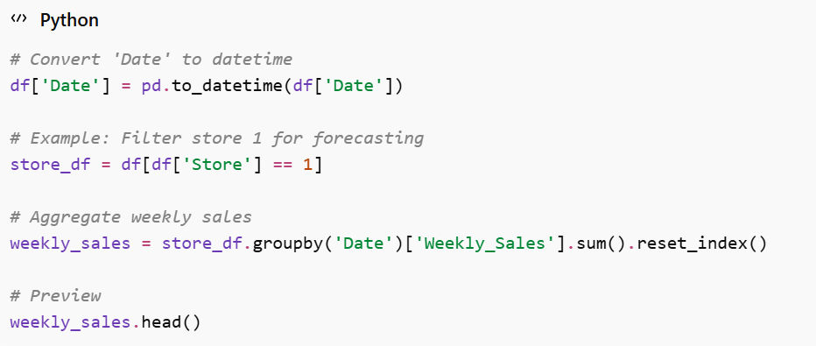
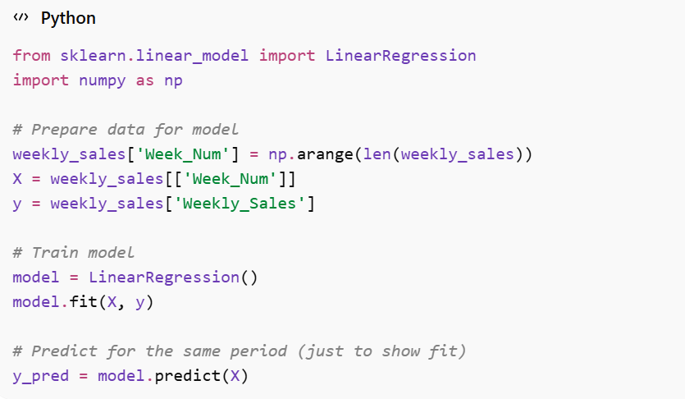
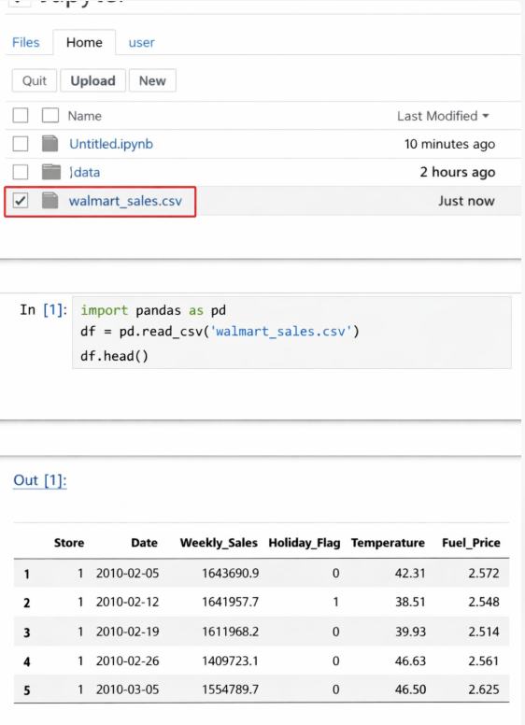
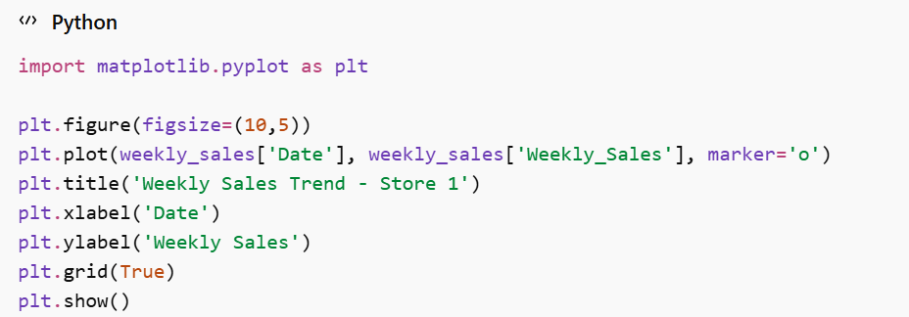
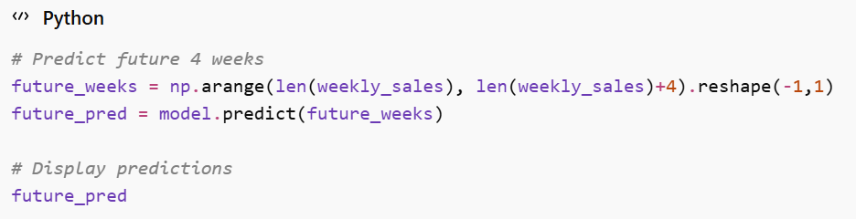
Task 4: Azure Cloud Exploration
Explore Azure cloud services and understand how to deploy or run analytics in the cloud.
Step 1:
- Sign in to Azure Portal
  - Go to https://portal.azure.com
  - Use your student/organization account.
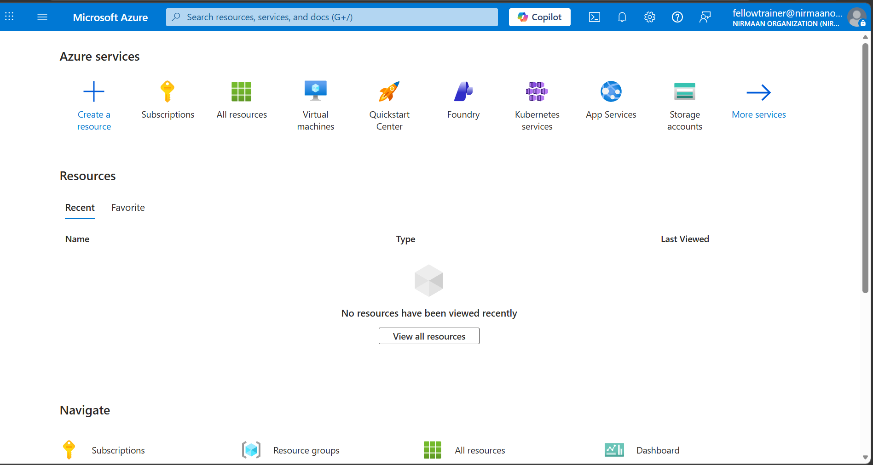
Step 2:
- Navigate Azure Services
  - Explore services such as:
    - Azure Machine Learning – for AI/ML experiments
    - Azure Storage – to upload datasets
    - Azure Virtual Machines – to run notebooks or Python scripts
    - Azure Synapse / Databricks – optional, for large-scale data analysis

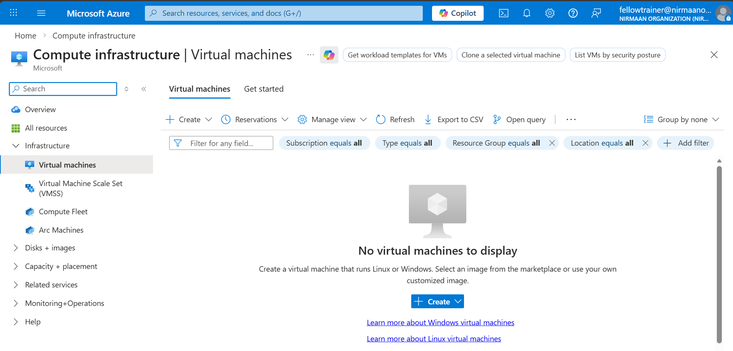
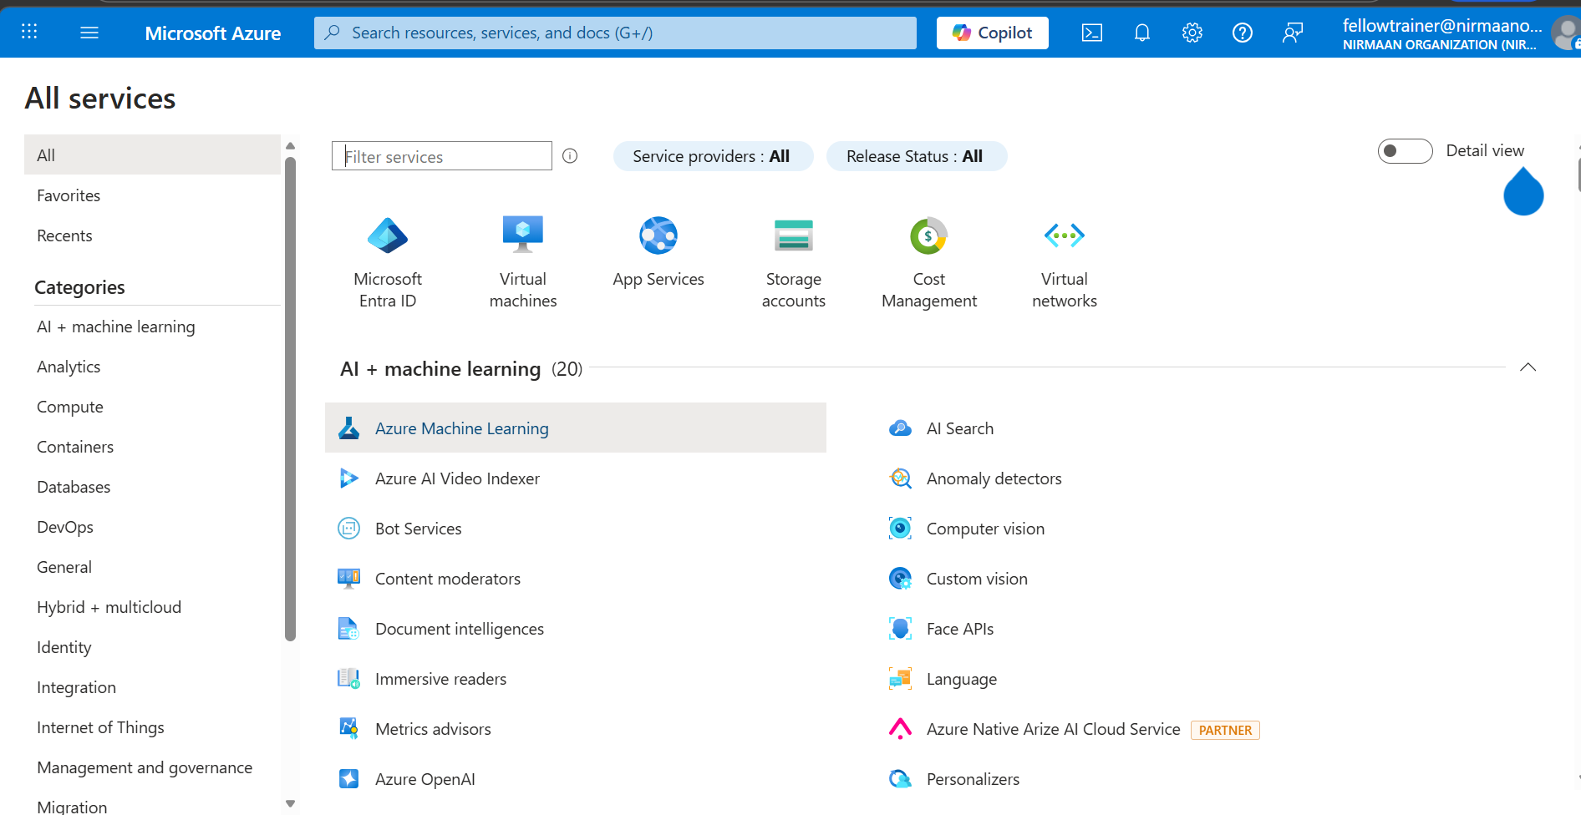
Step 3:
- Upload Dataset to Azure Storage (optional)
  - Create a new Resource Group (e.g., WalmartSalesRG).
  - In your Walmart_sales resource group page, click the + Create button.
  - Search for Storage Account in the marketplace and select it. (Standard, LRS)
  - Create a Storage Account (Blob Storage)
    - Go to Azure Portal → Storage Accounts → + Create
    - Resource Group: select Walmart_sales (name you have taken)
    - Storage Account Name: walmarbs (must be unique)
    - Region: same as Resource Group
    - Performance: Standard
    - Replication: LRS (Locally-redundant storage)
    - Click Review + Create → Create

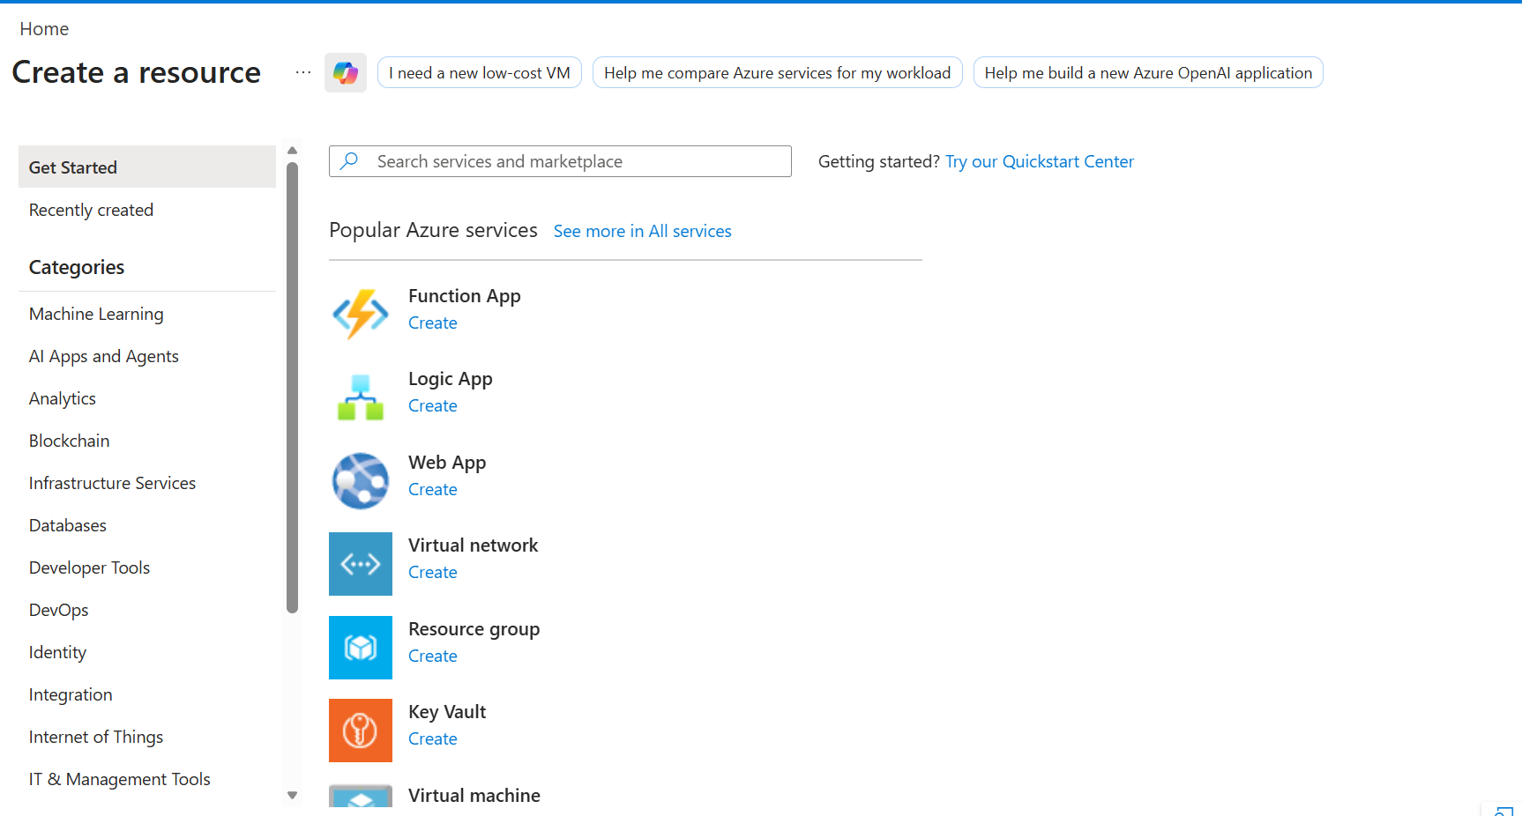
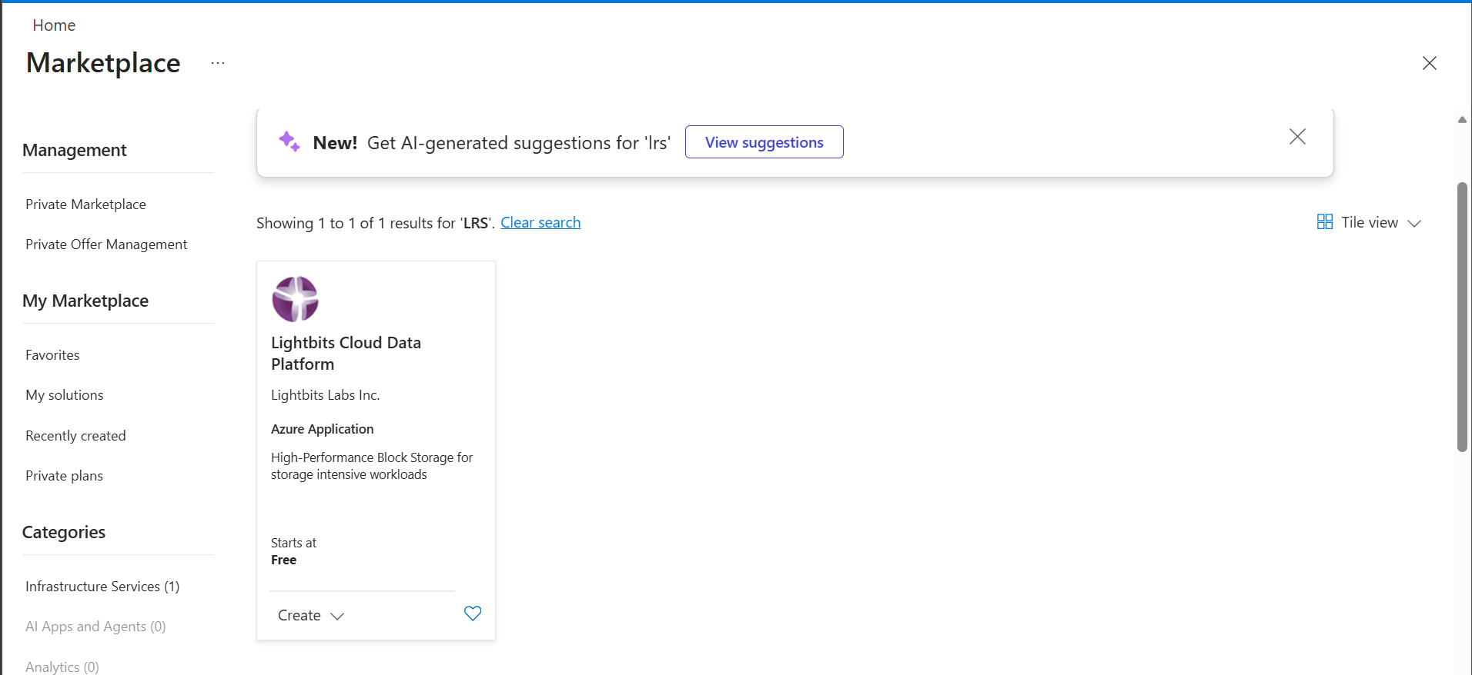
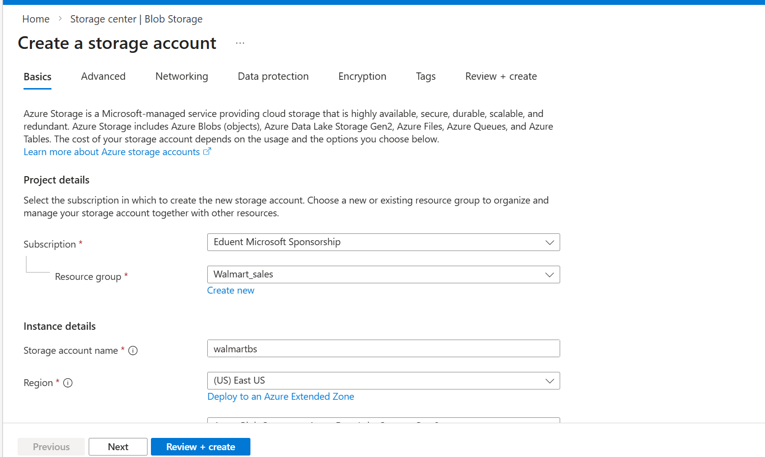
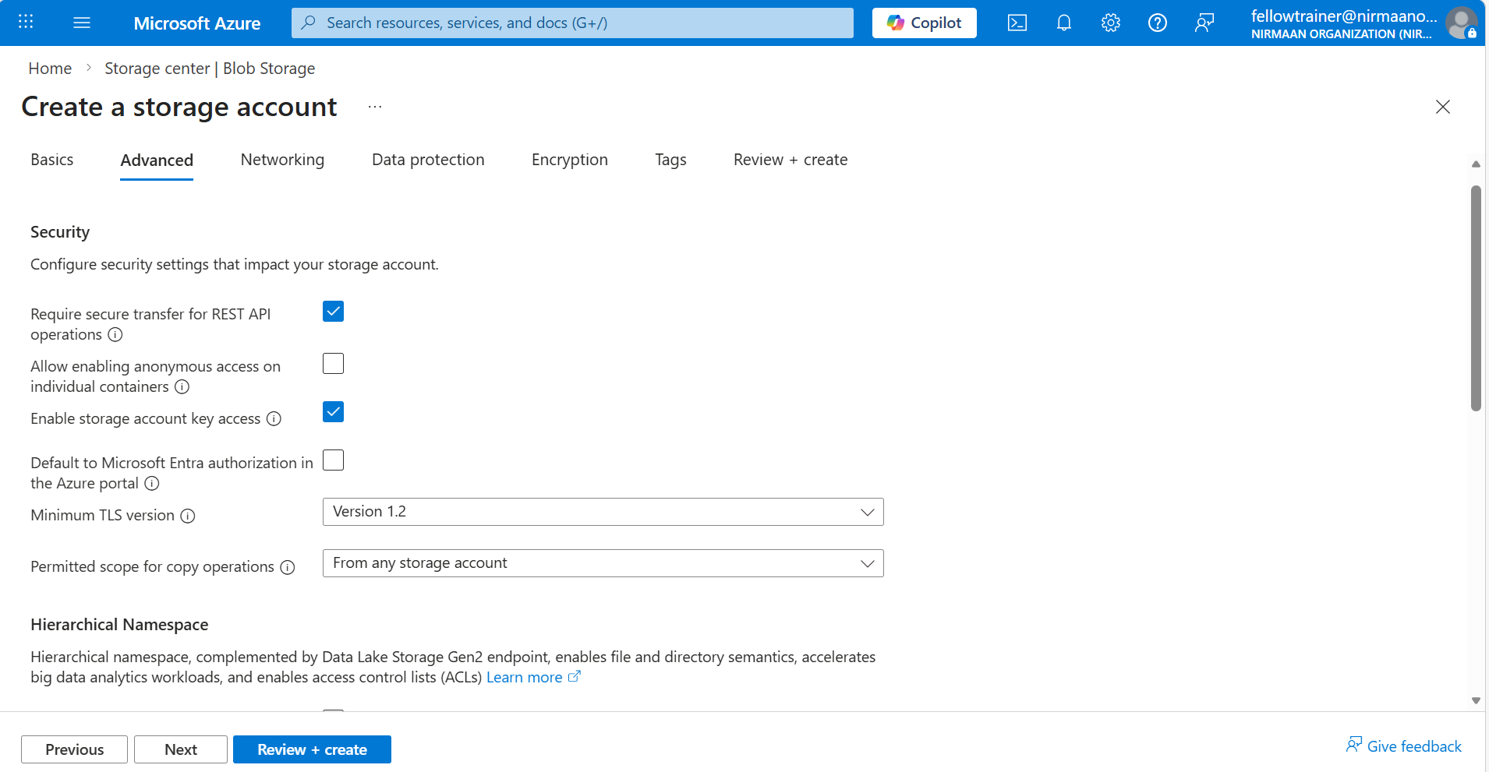
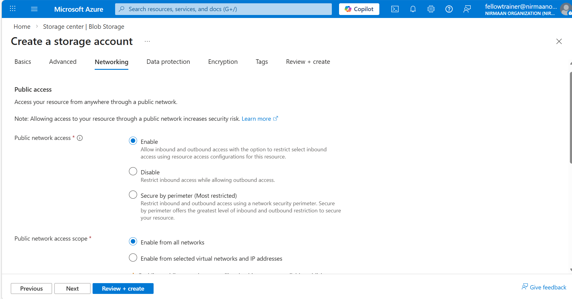
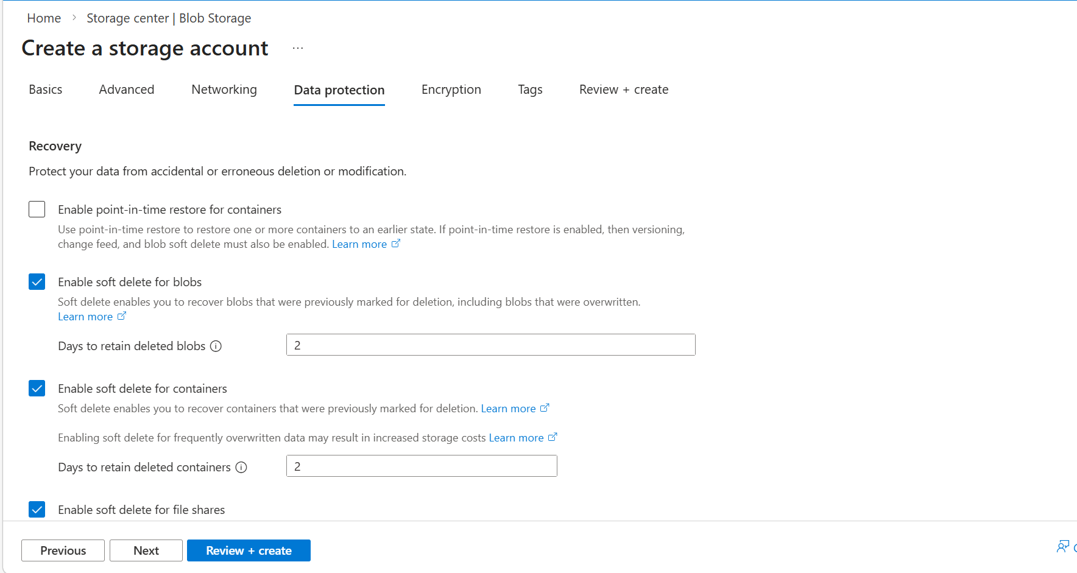
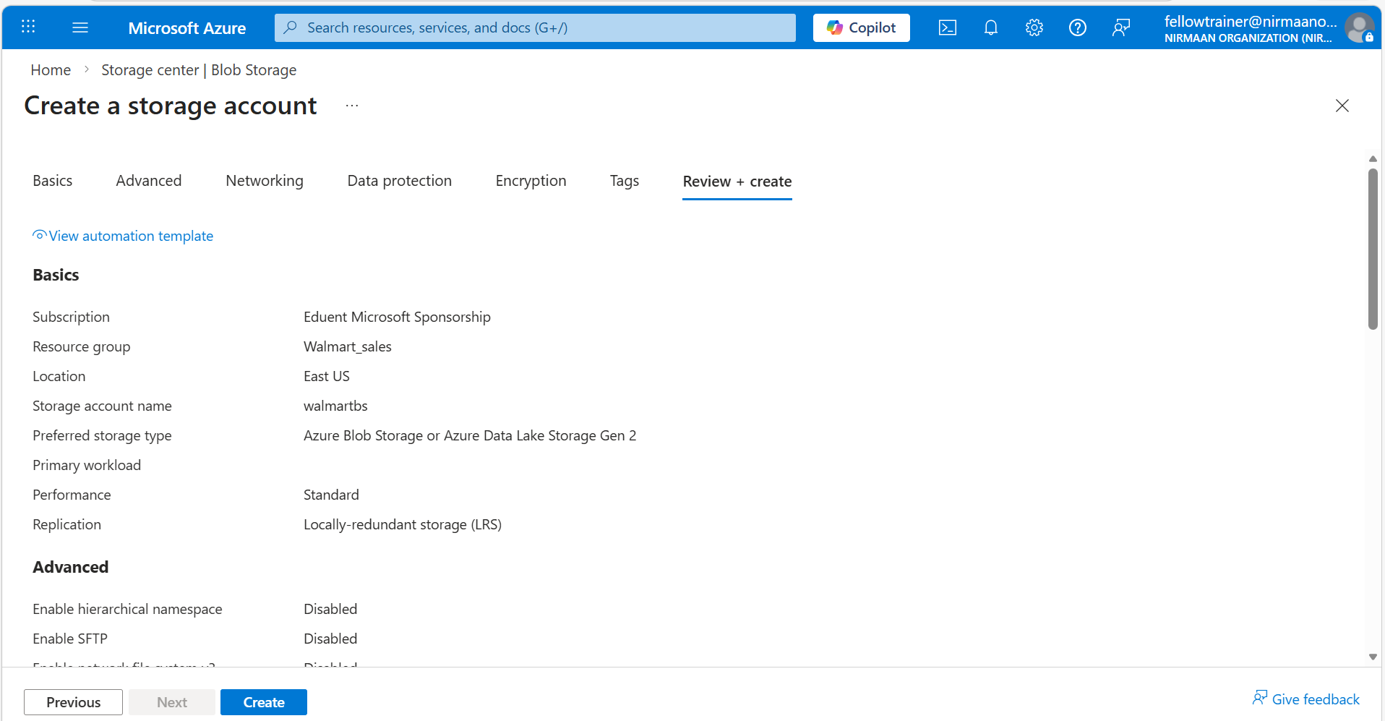
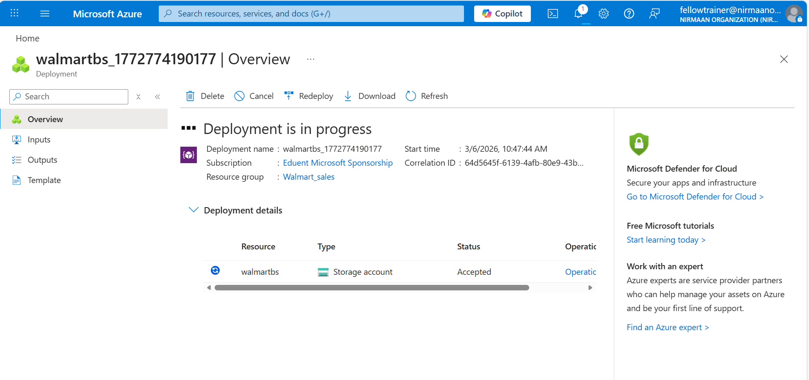
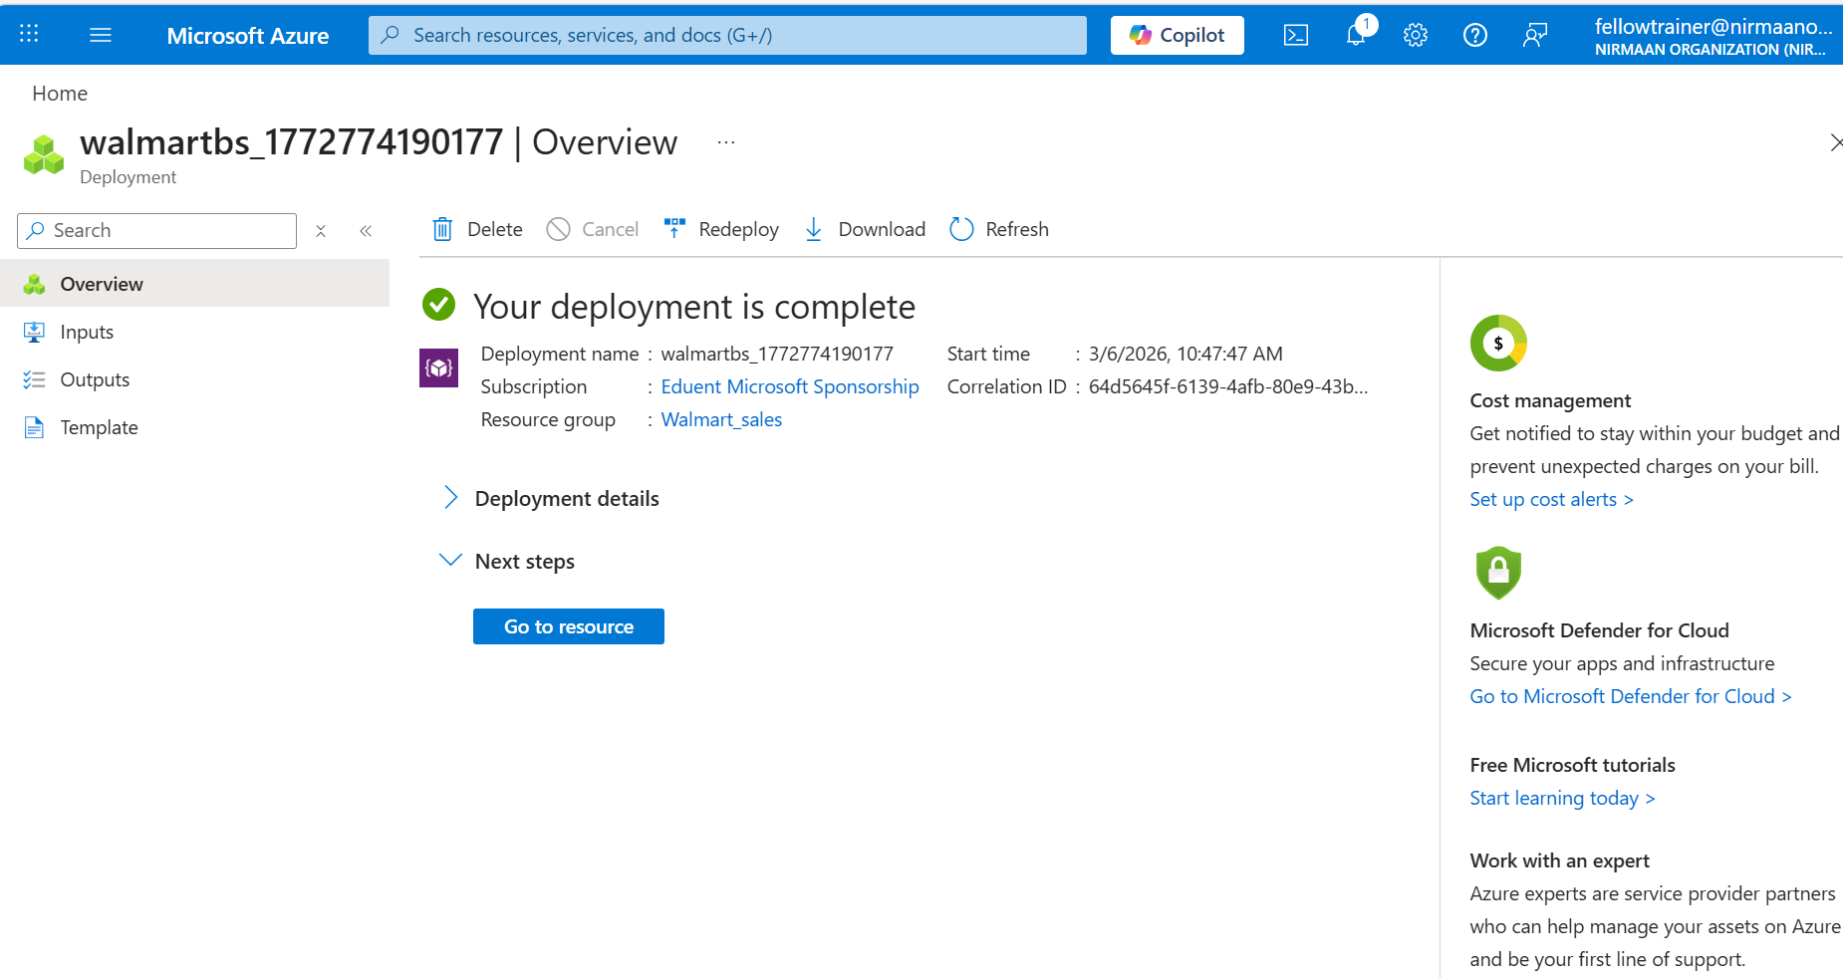
Step 4:
- Create a Container in Blob Storage
- Open your Storage Account → Containers → + Container
- Name: e.g., walmartdata
- Public access level: Private (default)
- Click Create
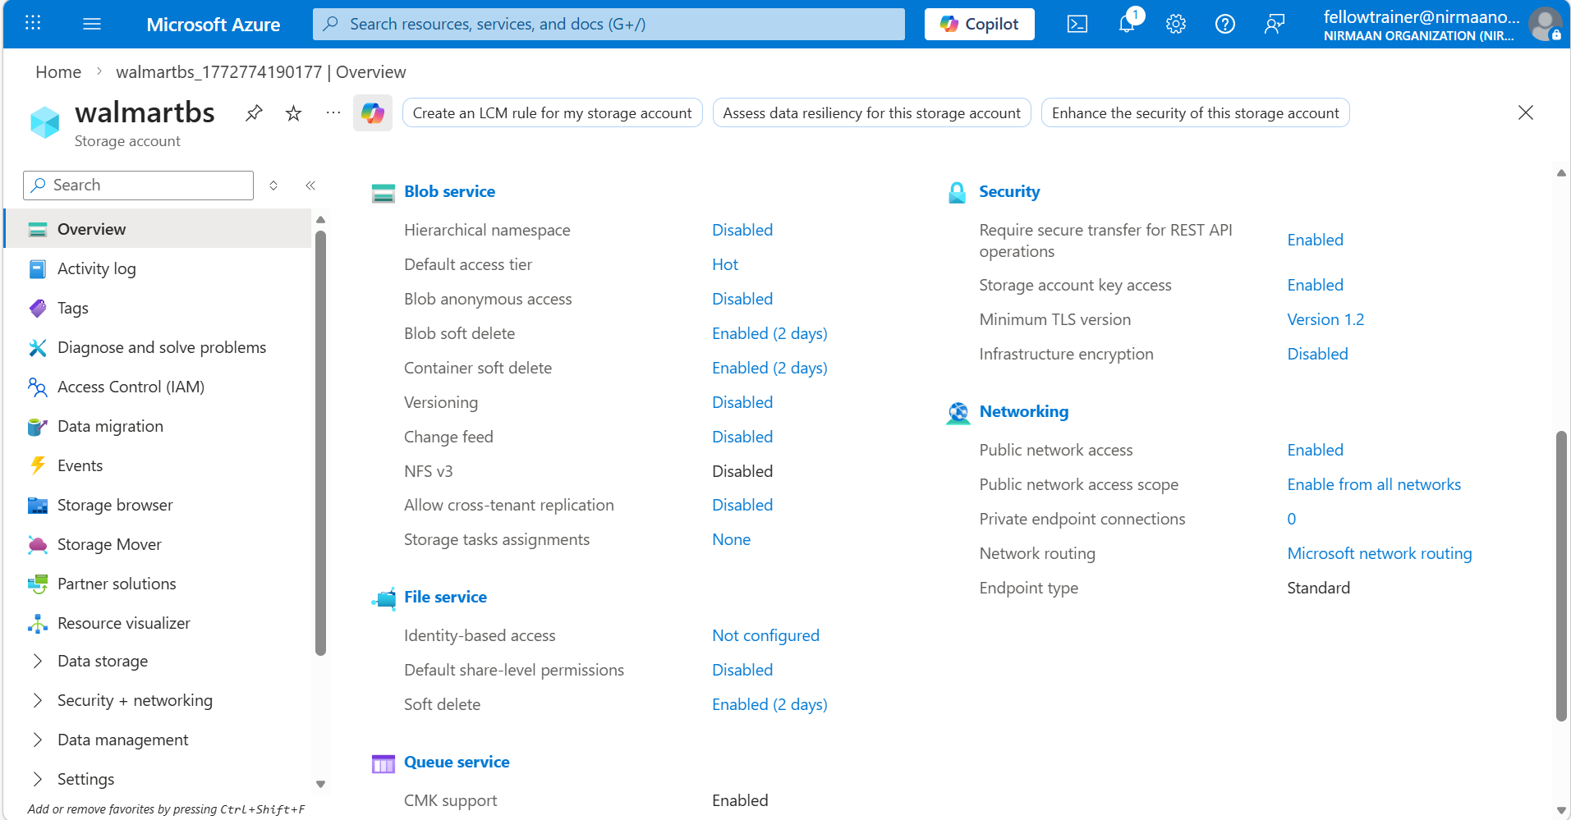

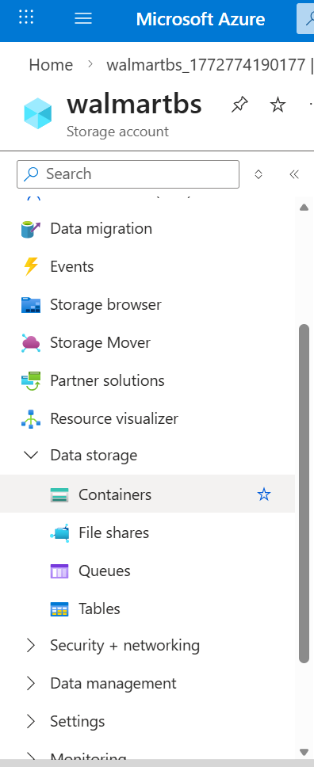
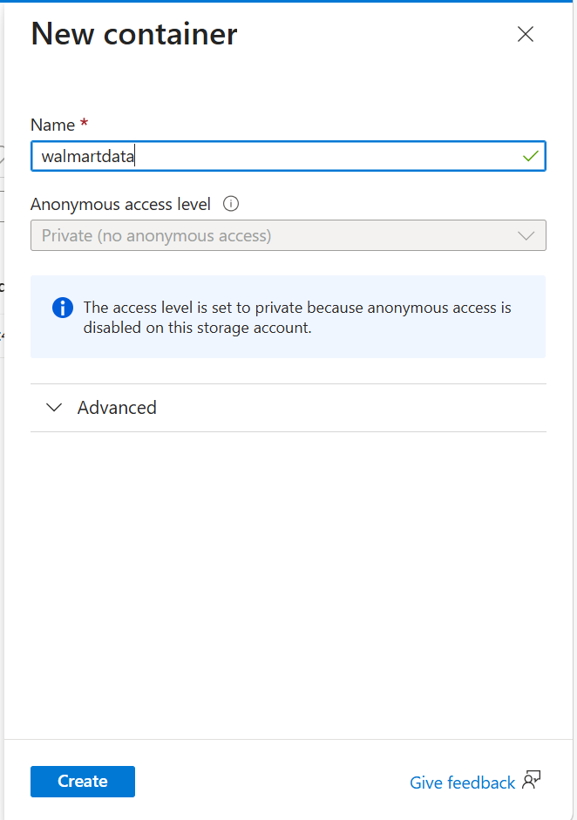
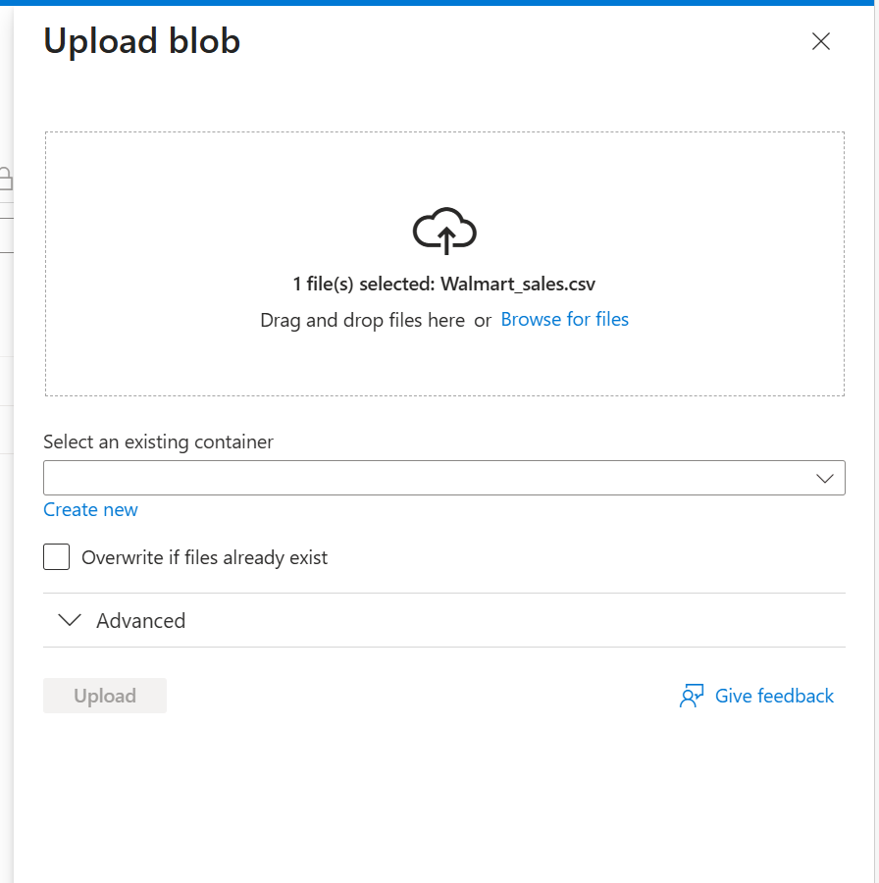
- Once uploaded, you can:
- Use SAS URL or Access Key to connect this storage to a VM or Jupyter Notebook.
- This allows your lab project to directly read data from Azure Blob.
Step 5:
- Explore Azure Notebooks or ML Studio
  - Open Azure Machine Learning Studio
  - Start a notebook
  - Load the dataset (walmart_sales.csv) and try basic exploration
  - Just replace:
    - <your_storage_account> → your Azure storage account name
    - <your_container> → the container name where the CSV is stored
    - <your_file> → the CSV file name
    - After running this, df will hold your Walmart sales dataset, ready for cleaning and analysis.

import pandas as pd
df = pd.read_csv("https://<your_storage_account>.blob.core.windows.net/<your_container>/<your_file>.csv")
Step 5:
- Observe Azure Tools
- See how cloud services handle datasets
- Note options for compute, storage, model deployment
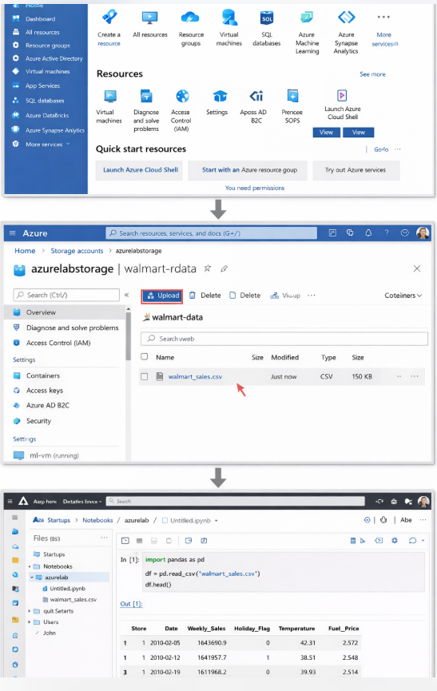
Conclusion:
This project demonstrates the end-to-end application of data analytics, machine learning, and cloud technologies on a real-world retail dataset.
The workflow integrates all the concepts learned in this lab:
- Step 1 Data Collection:
  - Students accessed and prepared the Walmart retail sales dataset, ensuring familiarity with dataset structures and the importance of reliable data sources.
- Step 2 Data Cleaning and Visualization:
  - Through data inspection, cleaning, and visualization, students learned how to identify missing values, handle data types, and visualize trends.
  - This step reinforces the importance of data quality and exploratory analysis before applying any modeling.
- Step 3 Demand Forecasting:
  - Students applied Python programming and GitHub Copilot to automate the creation of forecasting models.
  - By generating code for predicting future weekly sales, they understood how AI-assisted tools can accelerate model development and iterative experimentation.
- Step 4 Azure Cloud Exploration:
  - Students explored Azure services, including Azure Storage and Azure Machine Learning, to understand cloud-based data handling, storage, and computation.
  - This step emphasizes the real-world aspect of scaling analytics projects on cloud platforms and integrating AI/ML workflows with cloud tools.

This case study is not just about building a model; it integrates multiple skills data handling, programming, forecasting, visualization, and cloud computing into a cohesive project. Students now have a clear understanding of how analytics concepts and tools work together to solve practical business problems, providing a strong foundation for more advanced projects or professional applications in AI and data science.

